# **How to achieve a century long live life?**

Maxim Bilenkin

Department of Science and Technology, Bellevue University – Bellevue

DSC 500: Introduction to Data Science

Professor Fadi Alsaleem

October 3, 2024

## How to achieve a century long live life?

Many people today wondering how to live a long life. A lot of articles on the news available for this topic. Research and studies have been conducted on the diet and life styles of centenarians. But perhaps they are all contradictory. Some studies found eating good food is the answer. Another study found eating fewer or perhaps one meal a day will prolong our lives. Other surveys claiming breathing fresh air every day and regularly exercise are the keyingredient for longlife. All these findings make sense but at the same time contradictory**.** Many centenarians live in cities without fresh clean air, eating not thehealthiest foods, do not exercise and yet able to reach a century. So, what is the secret sauce to live a long life and reach a century? What do all centenarians have in common? Are there any similar patterns they have in common?

## 

One of the earliest studies on prolonging animals’ lives and reverse aging was done back in the ninety thirties by Clive Maine McCay, who was a professor of animal husbandry and scientist at Cornell University. In his study called “Caloric Restriction” he used A/B testing for two groups of rats (see for reference on last page). In one group he placed rats and fed them very little keeping the group nearly starved. The other group was fed well. What he discovered was the group that fed very little and kept semi starved lived thirty three percent longer than the other that fed well. Perhaps, may be the same principal can be applied to human beings? This study triggered many different research on how to reverse human aging. Scientist conduct all type of different experiments trying to discover the medicine or ways that will prolong our lives.

## How to achieve a century long live life?

Interviewing centenarians around the world form various insights and suggestions on how to live long life. It seems each group influenced in different part of the world by their culture, country, religion and believe. The advice they give varies. For example, in Japan long live people believe green tea, fresh air and sea food especially fish that is rich in omega-3 oil are the key to live a long life. But that is contradictory to the centenarians that live in the United States of American in big cities without breathing fresh air, eating burgers and pancakes.

Using Google Trends and running the following phrase “how to live to one hundred years” over the last twenty years returns not impressive interest in this topic around the world. The curve is flat from 2004 until October 2019. Very interesting phenomenon. Is it fare to say that people were not interested until October 2019 about how to live longer and then suddenly became very interested because of some event probably happened. And if that is the case then why in October 2019. Was there anything happening back then that finally triggered people’ interest on the topic? May be the Covid-19 pushed people to think more about their longevity and health. The global pandemic started in the second half of November 2019. At least the news start circling in the media. Perhaps that might be a good explanation as people strart getting more news about the topic they became more concern about their health and start searching for answers on Google. The World Health Organization officialy declared Covid-19 as global pandemic on January 30, 2020 according to the U.S. Department of Defence. See last page for refference.

## How to achieve a century long live life?

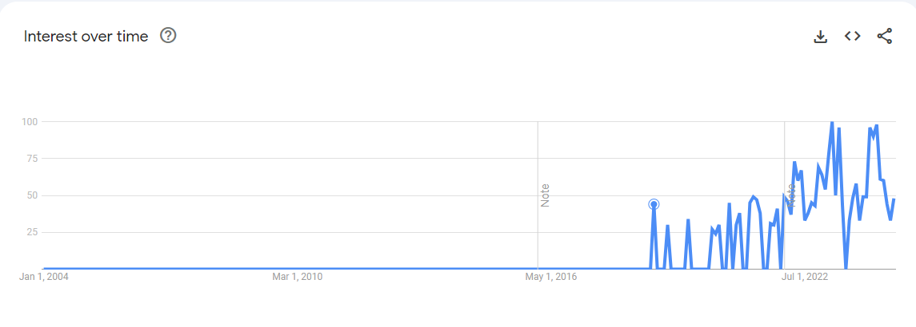

Apparently, taking as a single region the largest number of people that express interest about life longevity located in the North America. Accounting Philippines, Vietnam, and Indonesia as one group since all three located in Asia then we can see that the total number is overwhelmingly bigger than in the U.S. We know that the Covid-19 started out of Asia. It might be a good explanation the total number of individuals as a group were much higher in the region because their society were more informed ahead of North American population. Thus, more searches in total. 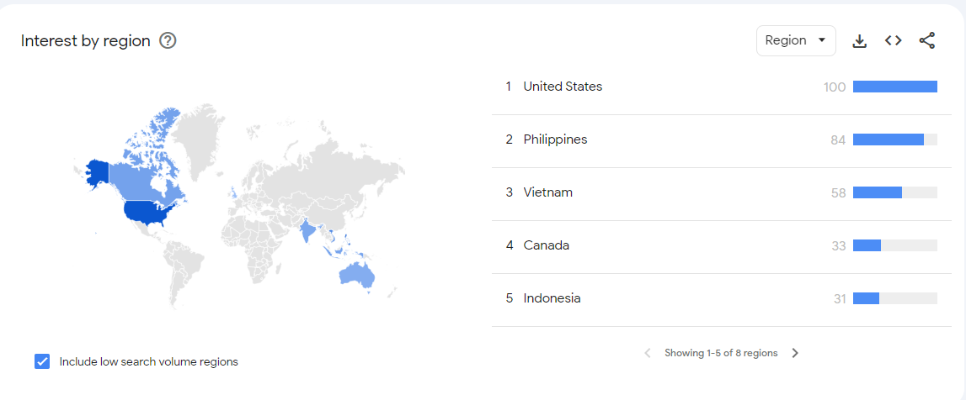

## How to achieve a century long live life?

Searching “100 years old person” returns more searches over time. At least beginning from March 2009 people in thirty regions expressed increasing over time interest in long living person’s life. This time Guyana was the leader. Doing my research on any event that happened back in March 2009 in Guyana I came across a big event that took place at that time. On March 29, 2009 the Los Angeles Times newspaper reported that Janet Jagan a U.S born former Chicago nursing student and the first female white person to become a President of Guyana has died at the age of 88 (please see last page for reference). Although, she did not live to 100, nevertheless this could be a good explanation that people especially women were interested how she was able to live relatively long live and start searching for answers. 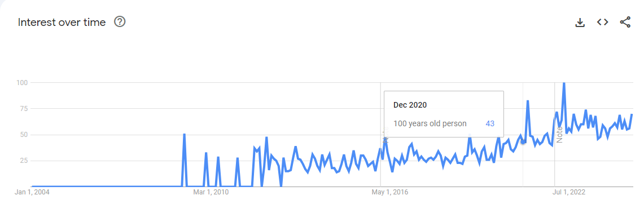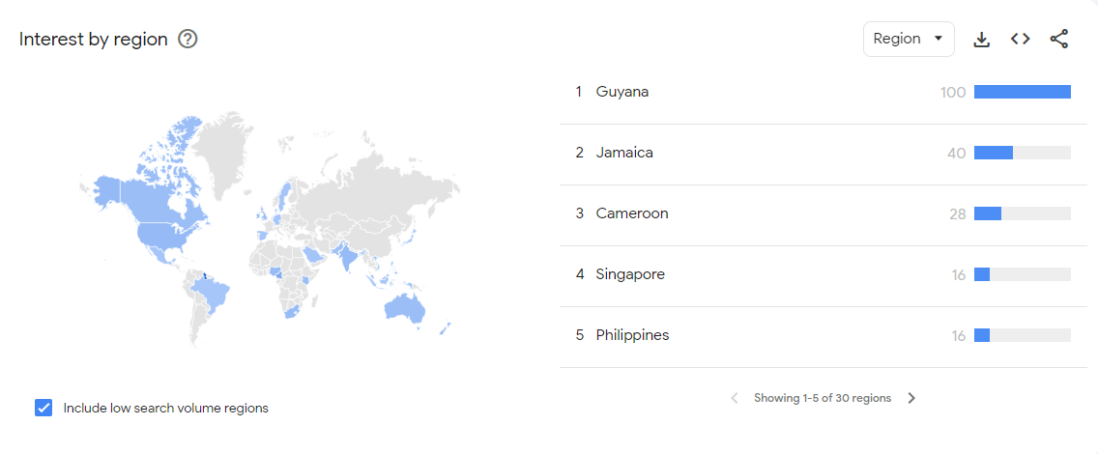

## How to achieve a century long live life?

Running search query “food for long live life” generates the following graph. Starting from March 2010 very low interest was expressed. But starting from the mid 2017 more interest in the food that can help to extend longevity and apparently more individuals from Nepal than any other were curious. Perhaps may be due to the study that was conducted on type 2 diebetes in Nepal from June 2017 and beyond on the food diet that people each made people more councious about their helth and they start searching for answers what food to eat to prolong their life. Plase see reference for source. 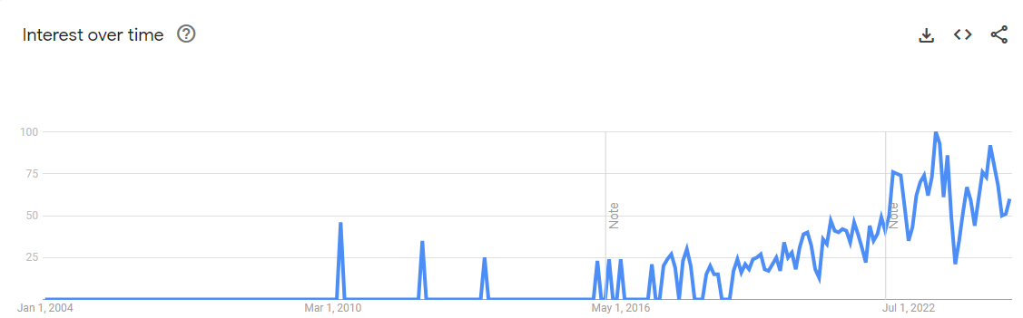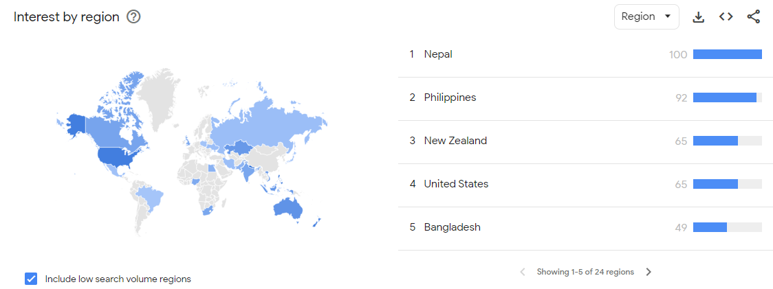

## How to achieve a century long live life?

Searching for “Do vegetarians live 100 years” returned only interest from Azerbaijan back in February 2009 which does not give any insight. There were no major events happened in the country during the time. Only one study was conducted by Internal Displacement Monitoring Center or simply IDPC on July 14, 2008 which was far before February 2009 (see last page for reference). The article called “Azerbaijan: IDPs still trapped in poverty and dependence” on page 7 under a header “Health of IDPs and accessibility of health care” describes about health and availability for displaced people. Probably the same situation applies to the entire country. It is not a secret after the collapse of the Soviet Union, Azerbaijan at least at the time when the survey conducted did not have a good health system available to its population. So, perhaps people in the country stopped relying on their government and began searching for answers on how to prolong their life. 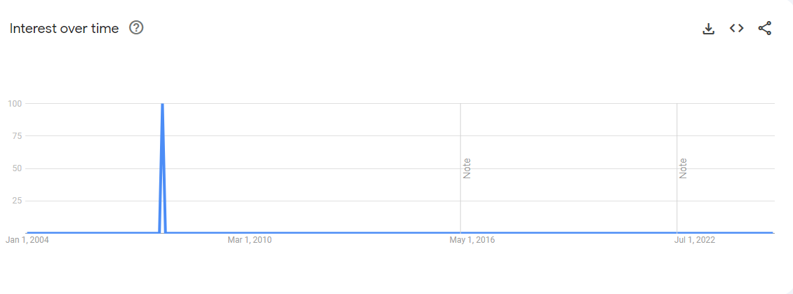

## How to achieve a century long live life?

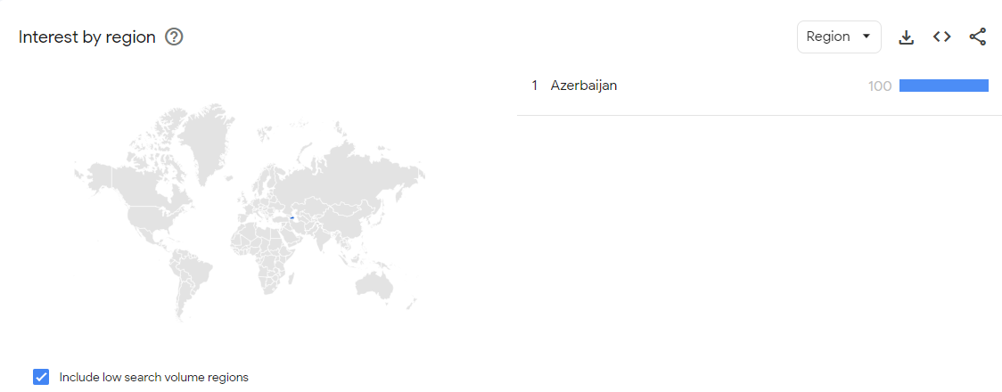

Finally, searching for “should one exercise to live longer” returns interest of over 100 searches and the most interested individuals located in Togo, the country I had never heard of in West Africa. It was reported by the news that Emmanuel Adebayor a Real Madrid soccer striker returns to Togo (Please see reference for source). This could trigger peoples’ interest to find out if they should exercise by playing soccer or other sport to live longer.

## 

## How to achieve a century long live life?

## 

Going back to the main question on “How to achieve a century long live life?” For sure centenarians share at least one strong common trait. They do not smoke! It makes a lot of sense and I strongly agree with this. From my own mid life experience, I never knew or saw a hundred-year-old person smoking. Smocking impacts almost every part of our body. It causes heart disease, deteriorates vision, impacting our brain, and the worse it causing a permanent lung cancer that cannot be reversed. According to the American Cancer Society, after a patient diagnosed with lung cancer on average lives only five years (see last page for source).

How about breathing fresh air. Does it prolong longevity? At the beginning I mentioned that many centenarians live in cities without fresh air and yet able to reach a century. That statement was a little bit vague. After doing some research online I found out that there are only five blue zones in the world where population of long-lived people is the highest. In the United States only one city called Loma Linda in the state of California that has the highest

## How to achieve a century long live life?

concentration. According to the World Population Review, as of 2024 population of Loma Linda stands at 25,185 (see reference page for source). That is not a big city or perhaps it should be called a town compared to New York or Los Angeles where population several or many millions larger. One can imagine how millions of cars, trucks, and houses heavily polluting air in large cities. I think we can conclude that the air in smaller cities is cleaner and fresher relatively to big once. Digging deeper, there are 9,000 people of Aventis community that are long live. Many lived to 100 or more (see reference page for source). I am sure there are centenarians in big cities as well but probably not many. It is obvious the air quality in a big city more polluted and it would be very hard to live up to 100 years while breathing unhealthy polluted air. A clear distinction should be made between small and big city. There are many 100-year-olds and older live in cities. But likely the majority live in a small cities or towns and breath relatively fresh air.

How about if one live on the edge of a big city near ocean or forest? Could that help to breath fresh air? I believe it could. The air quality is higher and less polluted in these areas since the frequent wind from the ocean and forest blowing and refreshing air by taking away pollution. According to the article “Clean Air, Longer Life” that was published by Harvard Magazine (see reference page for source). Every day we breath 20,000 liters of air. Also, research was conducted during a life span of 20 years and proved that the cleaner air people breath the longer they live. Cities known for worse air pollution were compared to the cities with a lot cleaner air. The researchers discovered that on average people live 10 months longer in cleaner air cities. Professor of environmental epidemiology at Harvard and senior author Douglas Dockery says “It is a dramatic gain.”

## How to achieve a century long live life?

Just looking at the below map have you noticed something? There is a one common pattern all blue zone locations have in common? They are all located near or next to the oceans or seas! Since we live in the US, let us take as an example Linda Loma in California. We can see that the city is 90 minutes away by drive surrounded by mountains and forest. Driving one hour and a half by car may be sounds a long time but for a wind that is constantly blowing with a current stream from the ocean that is not a long distance to travel. 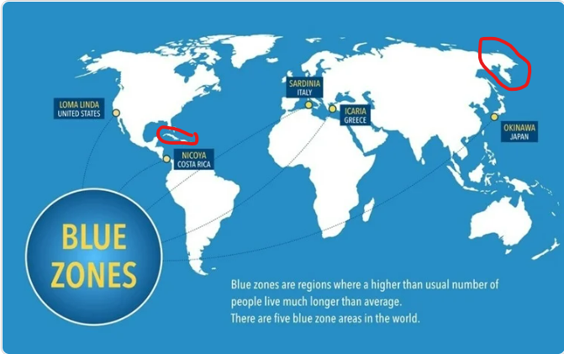

(Source: <https://www.news-medical.net/health/Unlocking-the-Secrets-of-Blue-Zones-A-Blueprint-for-Longevity-and-Health.aspx#1>)

There are still many locations around the world where people reside next to the water. For example, I had circled two places in red to identify three other counties just to expand further

## How to achieve a century long live life?

on my analysis. On the left side the circle represents Cuba and Dominican Republic. On the right side its Chukotka region in Russian Federation. The first question probably that pops up in our head is how come people in those regions are not included in Blue Zones? That is a very

legitimate question for one to ask. The reason might be having to do with the life style people live in those regions. For example, everybody knows about famous Cuban and Dominican cigars. Its no secret people in those part of the world not only selling their famous cigars to the world but also consuming it themselves.

Quick search on Wikipedia shows that as of 2007 smoking in Cuba accounted for 45% of population (see reference page for source). That is a very high rate. Although, 2007 may be outdated number. Nevertheless, it takes a long-life process of avoiding bad habits in order to live a long life. Someone who smoked in 2007 most likely will experience health issues further in life due to the smoking that happened back in 2007. It is a compounding long life process. To put it another way, one cannot keep smoking until 75 and then quit smoking and live another 25 years until 100. The damage already had been done and probably irreversible. Similar picture in Dominica Republic. Although the rate as of 2019 and it stands at 11%. Still, this is a very high rate and government of Dominican Republic calls it as epidemic that needs to be addressed immediately. It is a well-known fact that tobacco is no good for health and it shortens human life. It causing a lot of havoc in our body and negatively impacts almost every organ. Thus, it might be a big reason that both countries have average life expectancy of 78.3 years for Cuba and 72.6 years for Dominican Republic. While average life for men is 89 and for woman is 91 in Linda Loma, California according to Los Angeles Times article (see reference page for source).

## How to achieve a century long live life?

How about a place where tobacco plants do not grow due to the harsh cold climate condition. What could be the issue there that prevents people to live up to 100 years old. According to the CEIC Data which provides global economic data the average life expectancy for Chukotka reported at 66.56 years in 2023 (see reference page for source). The red circle on

the right side on the map represents Chukotka Region. The area scattered along three seas of Chukchi Sea, East Siberian Sea, and Bering Sea. There is no pollution. The air is fresh and cold. People cannot grow much of the vegetable because the growing season short that lasting from 80-100 days. We all know how vitamins and minerals are vital for our body. It improves our health, immune system and possible prolongs our life. But for Chukchi who are the native people of the region that mostly hunt sea mammals and whales for consumption most vegetables and fruits do not exist. The big shortage of vitamin source that come from plants might be the biggest factor why people in Chukotka have such a low life expectancy.

## Conclusion

Clearly, we can see from the Google Trends over the twenty years’ time span the overall interest is not that big on how to achieve a century long live life. In addition, it does not give much insight on how to achieve it. It shows peoples’ interest on finding the answers but doesn’t tell us what directions we should take. I would like to find out what in common centenarians have. What habits, foods, and life style do they share. All these findings hopefully will give some clue and pattern that will finally uncover the secret of achieving century old live life. I think we can conclude that there is no single solution to live a long life. One cannot combine good and bad habits and expect live long. Instead, it is a combination only of a healthy factor that are only effective as a group and when combined only then they can impact our life longevity. One who breaths fresh air but smokes will not live long. On the other hand, breeding only fresh air and not smocking will not be effective either in isolation. But, if you combine many good habits such as healthy eating, breathing fresh air, and constant exercising. Then you have a much higher chances of reaching 100 or higher mark.

## References

The Journal of Nutrition. Honoring Clive McCay and 75 Years of Calorie Restriction Research

<https://www.ncbi.nlm.nih.gov/pmc/articles/PMC2884327/>

The Economist. Longevity: can ageing be reversed?

<https://www.youtube.com/watch?v=FYr04ymjD1w&t=403s>

U.S. Department of Defence (Coronavirus Timeline)

<https://www.defense.gov/Spotlights/Coronavirus-DOD-Response/Timeline/>

Los Angeles Times

<https://www.latimes.com/local/obituaries/la-me-janet-jagan29-2009mar29-story.html>

Perceived impact of Nepalese food and food culture in diabetes

<https://www.sciencedirect.com/science/article/abs/pii/S0195666317303677>

Adebayor returns for Togo

<https://english.ahram.org.eg/NewsContent/6/54/8378/Sports/Africa/Aboutus.aspx>

State of emergency medicine in Azerbaijan

<https://www.ncbi.nlm.nih.gov/pmc/articles/PMC2536184/>

Lung Cancer Survival Rates (American Cancer Society)

<https://www.cancer.org/cancer/types/lung-cancer/detection-diagnosis-staging/survival-rates.html#:~:text=Survival%20rates%20can't%20tell,5%20years%20after%20being%20diagnosed>.

Loma Linda, California Population 2024

<https://worldpopulationreview.com/us-cities/california/loma-linda>

This small California city is home to America’s longest-living people

<https://www.cnbc.com/2023/09/26/loma-linda-ca-what-the-only-blue-zone-in-the-us-does-for-longevity.html#:~:text=Health%20and%20Wellness-,People%20live%20longer%2C%20happier%20lives%20in%20Blue%20Zones%2C%20and%20only,5%20things%20they%20do%20differently&text=Of%20the%20five%20blue%20zones,one%20is%20in%20the%20U.S>.

Clean Air, Longer Life

<https://www.harvardmagazine.com/2009/05/clean-air-longer-life#:~:text=When%20it%20comes%20to%20personal,the%20longer%20you%20will%20live>.

Smoking in Cuba

<https://en.wikipedia.org/wiki/Smoking_in_Cuba>

Adult smoking prevalence in Dominican Republic is 11%.

<https://tobaccoatlas.org/factsheets/dominican-republic/>

Loma Linda residents live a really, really long time.

<https://www.latimes.com/opinion/op-ed/la-oe-goldberg-loma-linda-healthcare-20170530-story.html#:~:text=Loma%20Linda%20has%20one%20of,longer%20than%20the%20national%20average>.

Life Expectancy at Birth: FE: Chukotka Area

<https://www.ceicdata.com/en/russia/life-expectancy-at-birth-by-region/life-expectancy-at-birth-fe-chukotka-area>